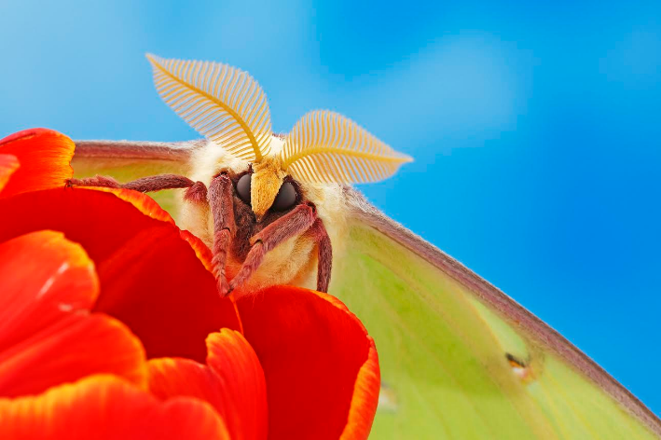**

**Annual Photo Contest**

2015 winning photo by Tom Myers

Dear NCES Members,

The North Carolina Entomological Society (NCES) annual photo contest is now open!

**TO ENTER:** Submit digital images (JPG format) of **living** arthropods to Kristi Backe ([kbacke@ncsu.edu](mailto:kbacke@ncsu.edu)). All images **must be received by Wednesday, October 26th**, to be eligible for judging, and each participant may submit a maximum of five images. The contest is open to members and non-members of the NCES. Please label each image with your name and the competition category (listed below). To ensure that your photo will display properly on-screen during judging, please submit high-quality image files (≥100 dpi, 2-3 MB).

**JUDGING:** All submissions will undergo preliminary review by a team of judges (NCES members), and the top five images in each category will be selected for final judging. The criteria for judging images will be determined by the judging team. The top five images in each category will be projected onto a screen as a slideshow at the NCES annual meeting and will be judged by those in attendance at the meeting. The annual meeting takes place on November 9th, 2016, at the J.C. Raulston Arboretum in Raleigh.

**CATEGORIES:**

1. Adult arthropods

2. Immature arthropods (including eggs)

3. Pollinators

4. Arthropods in action (i.e., behavior)

5. Unusual/Artistic (e.g,. extreme close-up)

6. Young photographer (any arthropod photo submitted by a contestant 12 years old or younger)

An image may be entered in only one category. Please specify a category for each photo when submitting images. Attendees at the annual meeting will vote for the “Best Image” in each category as well as a “Best in Show” photograph.

**RECOGNITION:** Winners of “Best Image” in each category and “Best in Show” will receive award certificates. Any photos submitted to the contest may be used by the society (e.g., NCES website, social media) with appropriate credit given to the photographer. In addition, the winner of “Best in Show” will have his/her image displayed on the 2017 annual meeting registration form with proper credit to the photographer.

If you have any questions about the contest or would like additional information on the annual meeting, contact Kristi Backe ([kbacke@ncsu.edu](mailto:kbacke@ncsu.edu)).We are looking forward to excellent submissions this year! Good luck!